1.A company has a base class Employee with attributes name and salary. Two subclasses, Developer and Tester, inherit from Employee. Each subclass has an additional attribute: programmingLanguage for Developer and testingTool for Tester.
Write a Java program using inheritance to display the details of both employees.
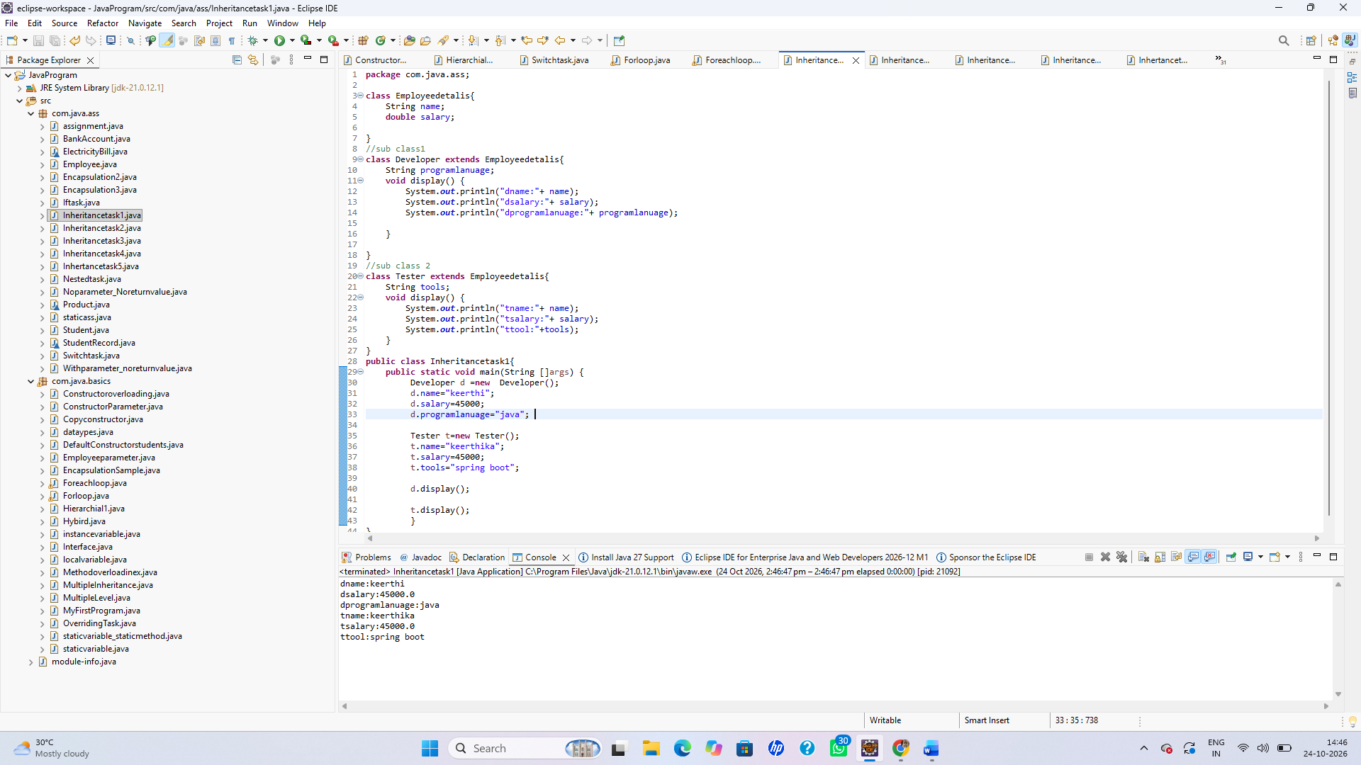
2. A rental company has a parent class Vehicle with methods start() and stop(). The subclasses Car and Bike inherit these methods and have their own method called displayType().
Implement inheritance and demonstrate how both subclasses reuse the parent class methods.
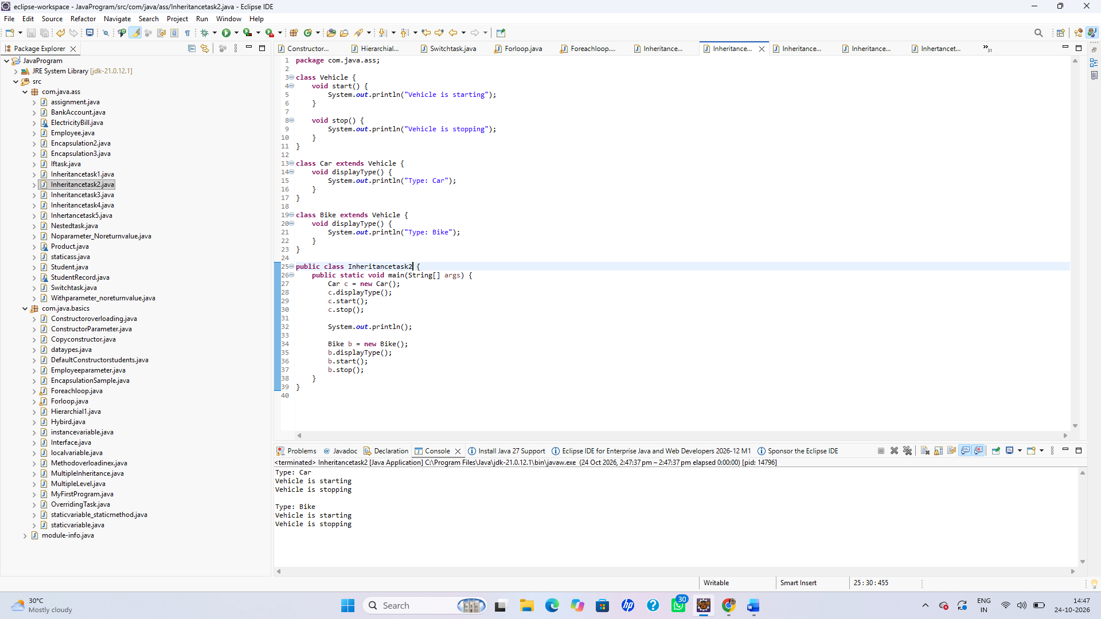
3. A banking application has three classes: BankAccount, SavingsAccount, and PremiumSavingsAccount. SavingsAccount inherits from BankAccount, while PremiumSavingsAccount inherits from SavingsAccount.
Write a Java program to demonstrate multilevel inheritance and display account details at each level.
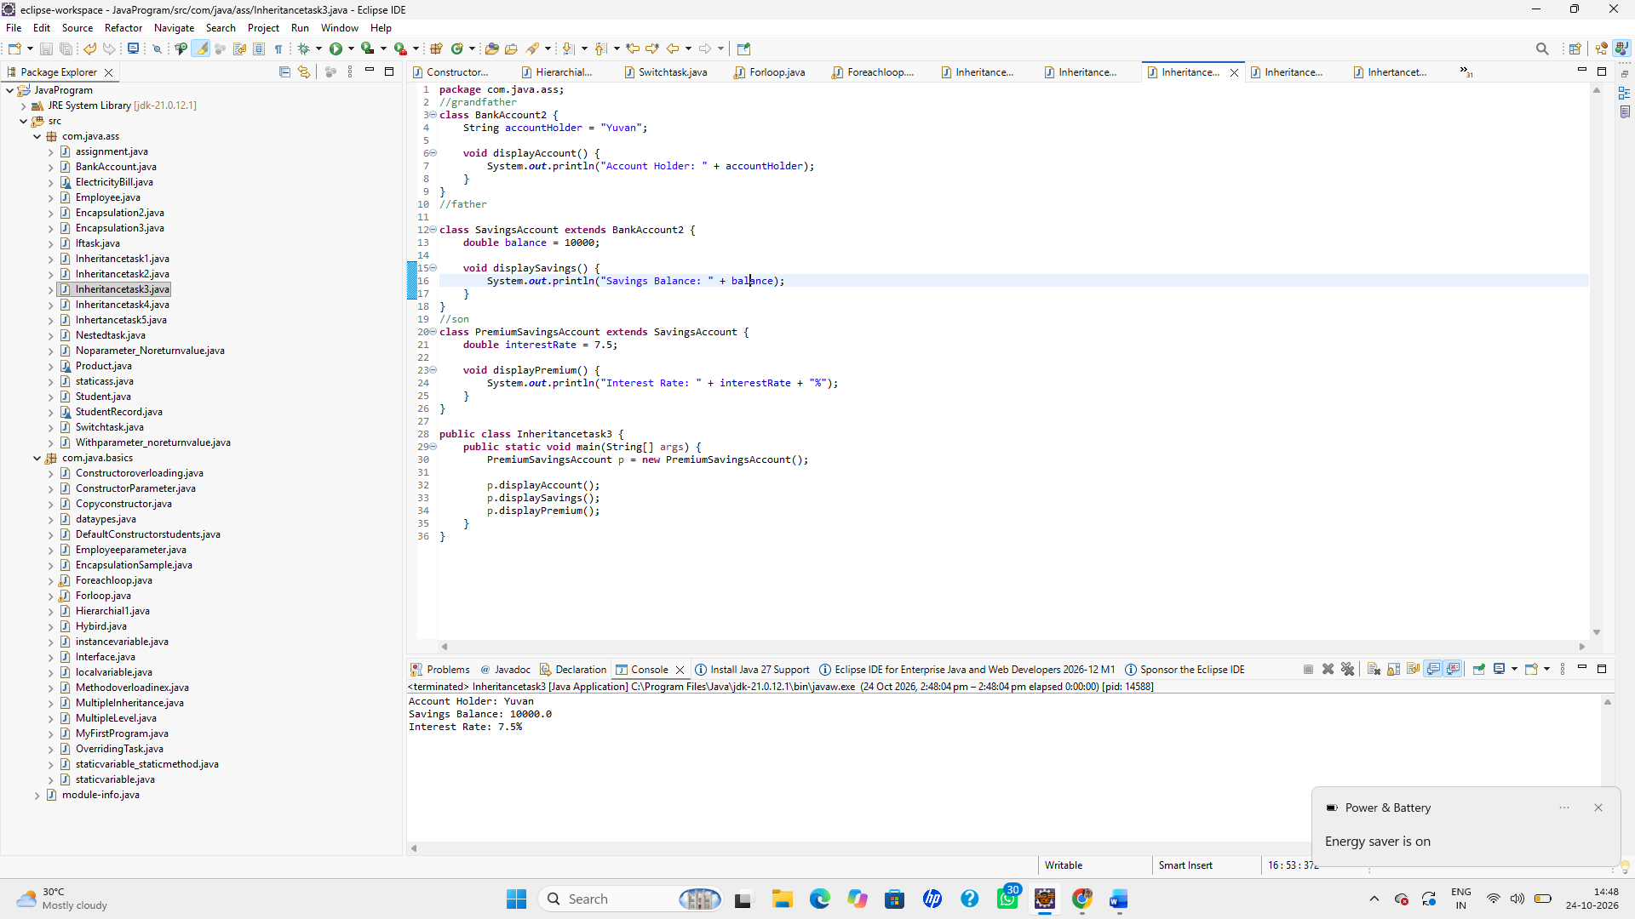
4.An online shopping application has a parent class Product with attributes productId and price. Three subclasses, Electronics, Clothing, and Books, inherit from Product and display their respective product categories.
Implement hierarchical inheritance and display the details of all three product types.
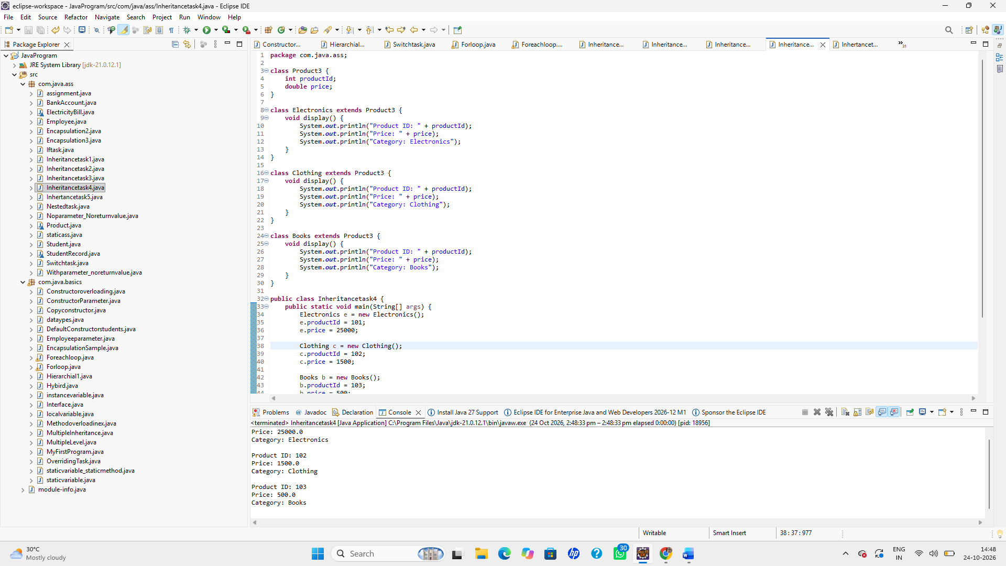
5. A university application has a parent class Person with a parameterized constructor that accepts name and age. A subclass Student has an additional attribute rollNumber. The subclass must initialize the parent attributes using super().
Write a Java program demonstrating constructor execution in inheritance using super() and display all student detail

